

Want to be inspired? Sit down with some of America’s great stories on faith!

“Conversations on Faith” offers readers an in-depth look into the lives, lessons and inspirations of a unique collection of men and women who have a rich heritage of faith.
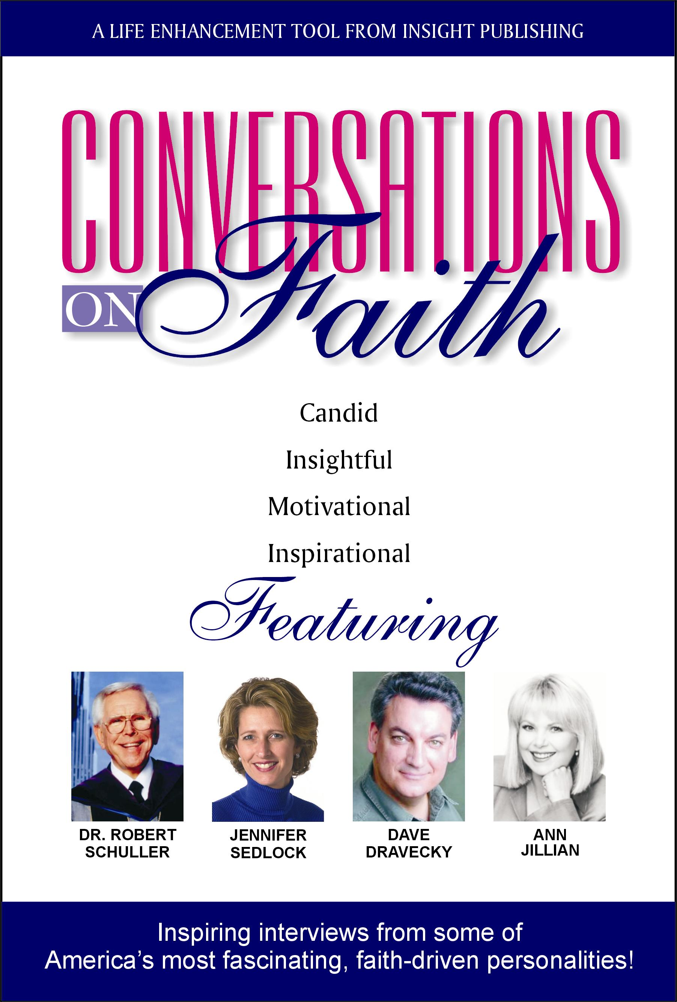
Jennifer Sedlock joins Dr. Robert Schuller, Dave Dravecky and Ann Jillian in this soon-to-be-released book on Faith!

Jennifer Sedlock, of Carlsbad, CA, has been hand-selected through a nationwide search to be a featured author in “Conversations On Faith” from Insight Publishing, to be released in Fall 2004. Also featured in this dynamic collection of interviews are Dr. Robert Schuller (world renowned evangelist and best selling author), Dave Dravecky (former Major League baseball pitcher and founder of Outreach of Hope) and Ann Jillian (Broadway, Motion Picture and TV actress, spokesperson and motivational speaker).
This exciting series captures the insights, strategies, and inspiration of faith-minded people and features the transcribed interviews of eighteen dynamic professionals who offer powerful lessons in faith.
Jennifer Sedlock is a professional speaker who has worked with over 50 organizations nationwide. She brings nearly 20 years of management and training experiences into her motivational presentations and educational programs. Sedlock earned a Business degree from the University of California, Berkeley and a Master’s degree in Organization Development from the University of San Francisco. “Running Toward Your Dream” and “Discovering Your Gifts” are her most requested programs. For retreats she presents how your Myers-Briggs® personality type affects your prayer and worship style. Jennifer would be honored to speak at your next event!
In today’s troubled world, “Conversations On Faith” is the perfect book for people wanting to refresh their faith and renew their strength. Reserve your copy today!

Contact Jennifer Sedlock
Speaking to the head and the heart, touching the soul
jennifer@jenniferspeaks.com
www.jenniferspeaks.com
760.635.3305

“These are fabulous interviews! Great reading for busy people who are looking for fresh perspectives and relevant motivation for people of faith”
Kenny Smith, Elder, Evergreen PCA Church

